Zigbee based Wireless Home Security System

Home Security has become an important issue everywhere. Safety from theft is the most important requirement of home security systems for people. The growing crime number across cities reflects the sour reality. Many people overlook, ignore, and underestimate the necessity for taking appropriate home security measures. Home security system gives extra peace of mind and security in everybody’s house while they are sleeping or even away from their home. The best home security system makes life safer and more comfortable. In this system, people will get all updates in their absence. This project comprises of two circuits, a transmitter part as well as a receiver part. The transmitter consists of three PIRs to indicate motion in three locations, a proximity sensor to detect whether the window is opened or closed, a temperature sensor to get the current temperature, an LCD to display the parameters and a ZigBee module. Zigbee is a low cost, low power, wireless mesh network standard and delivers low latency communication. The receiver circuit consists of a receiving Zigbee module, an LCD, and a GSM module for notifications. The communication between the two circuits is done by ZigBee Module. Whenever there is motion in any of the locations or an alert of the window getting open then a notification is sent to the registered user. And a bulb to turn on if the temperature goes down.

Block Diagram : 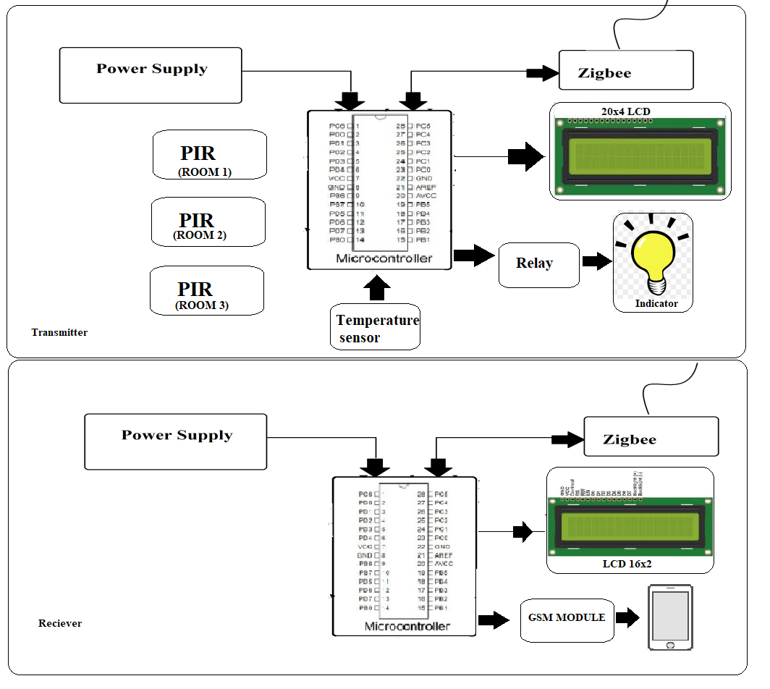

Hardware Specifications :
- Atmega328P

- Zigbee Module

- LCD

- PIR

- Proximity sensor

- Temperature sensor

- GSM module

- Crystal Oscillator

- Resistors

- Capacitors

- Transistors

- Cables and Connectors

- Diodes

- PCB and Breadboards

- LED

- Transformer/Adapter

- Push Buttons

- Switch

- IC

- IC Sockets
Software Specifications :
- Arduino Compiler
- MC Programming Language: C

